**Part 1: *How to create Github Repository:**

-Step 1: After you have registered your github account, and log in. You can create a Github Repository.

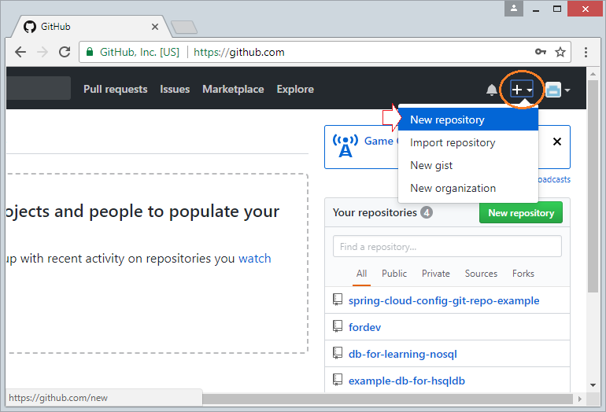

-Step 2: Enter a name in the **“Repository name”** box bellow, and choose **“Public”** if you want anyone to be able to see your respository.

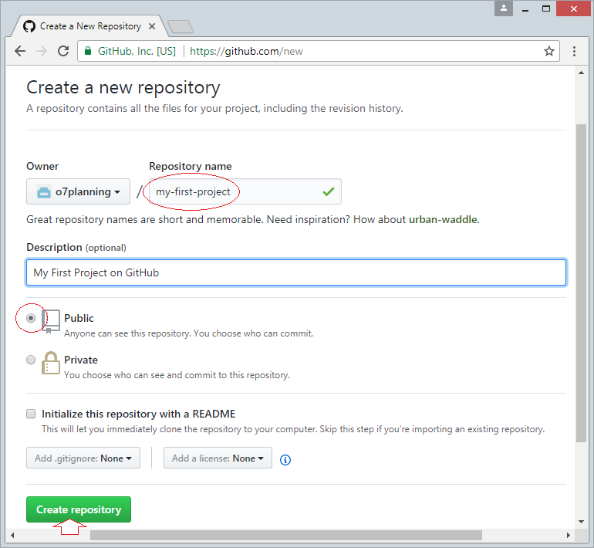  
A repository has been created.

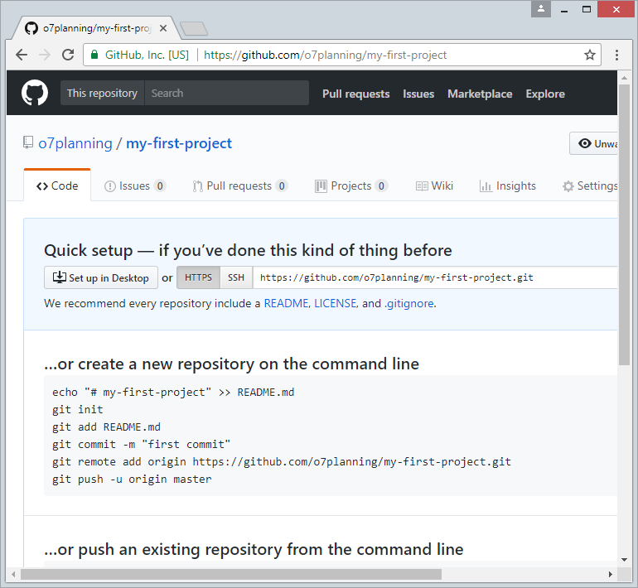

**Part 2: *How to delete the repository:**

-Step 1: Log in github, enter your username and password.

-Step 2: Go to settings:

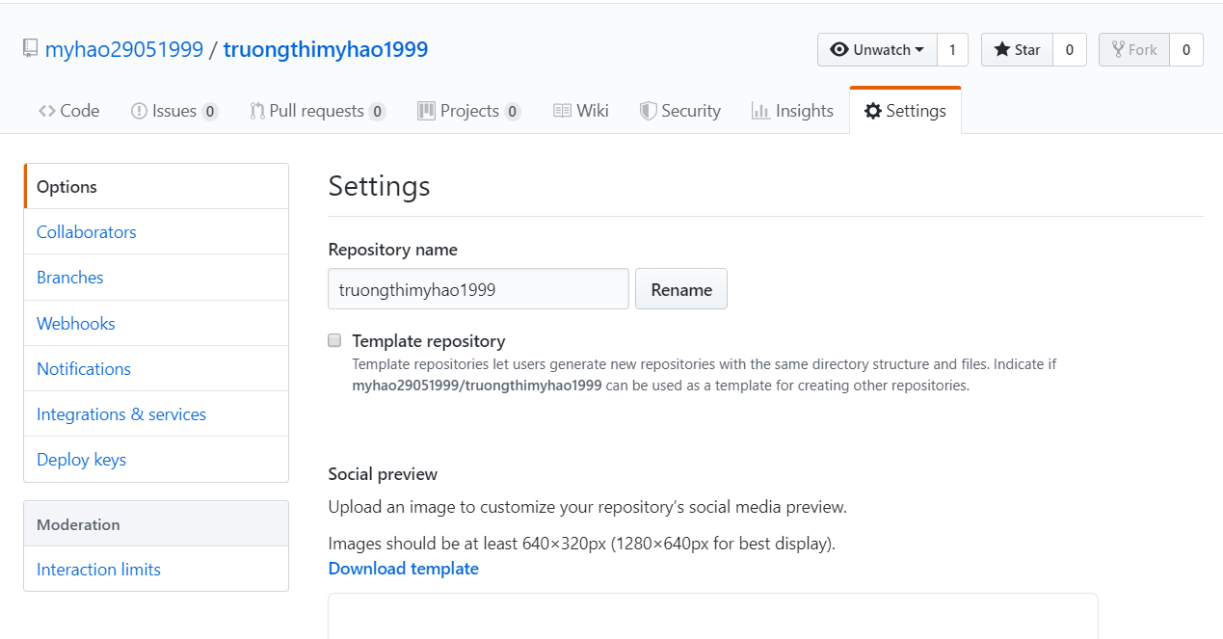

At section Danger Zone, you choose **“ Delete this repository”**, enter the name

repository and delete it.

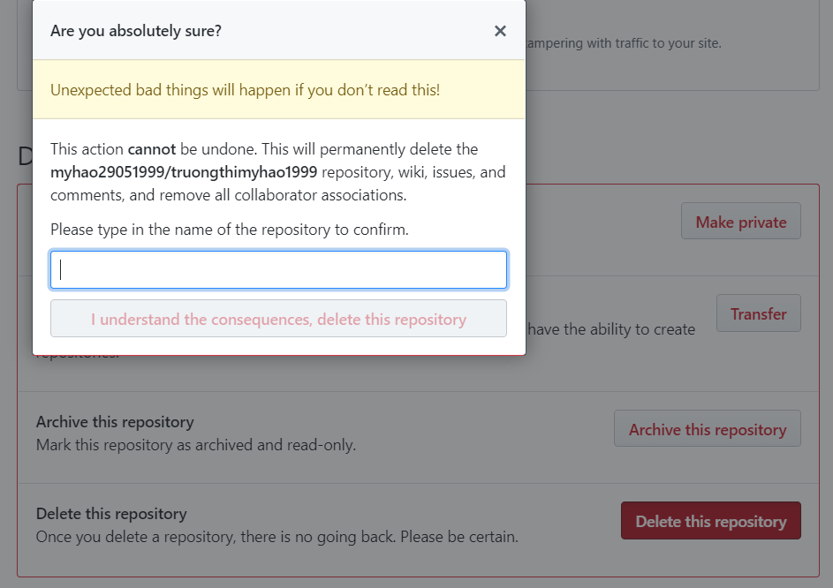

-*If you want to create a new repository, you can refer to the section above for instructions.*

**Part 3: *How to set up custom domain:**

- Enter the domain name that you created in **“Custom domain”** and **“Save”.**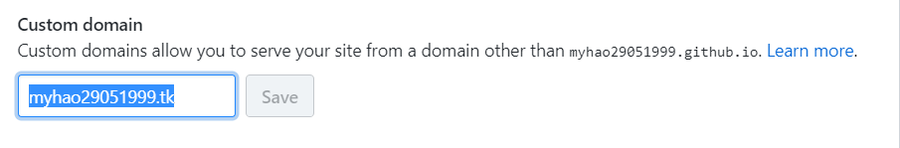

-The domain has been mapped successfully!

